**AWS – Amazon Transcribe Speech to Text Conversion**

This artifact is a walkthrough for Amazon Transcribe. This will be a new learning for people who have not use cloud storage systems like Google Big Table, Amazon S3, etc. To begin using any of the AWS services, we need to store the data we need to use in any of the AWS services. For instance, in our case to convert or audio file into text, initially we need to store the audio file in Amazon’s scalable storage in the cloud service called Amazon S3. Initially we must create an AWS account and then follow the steps given below:

**Step-1: Creating a storage bucket in Amazon S3**

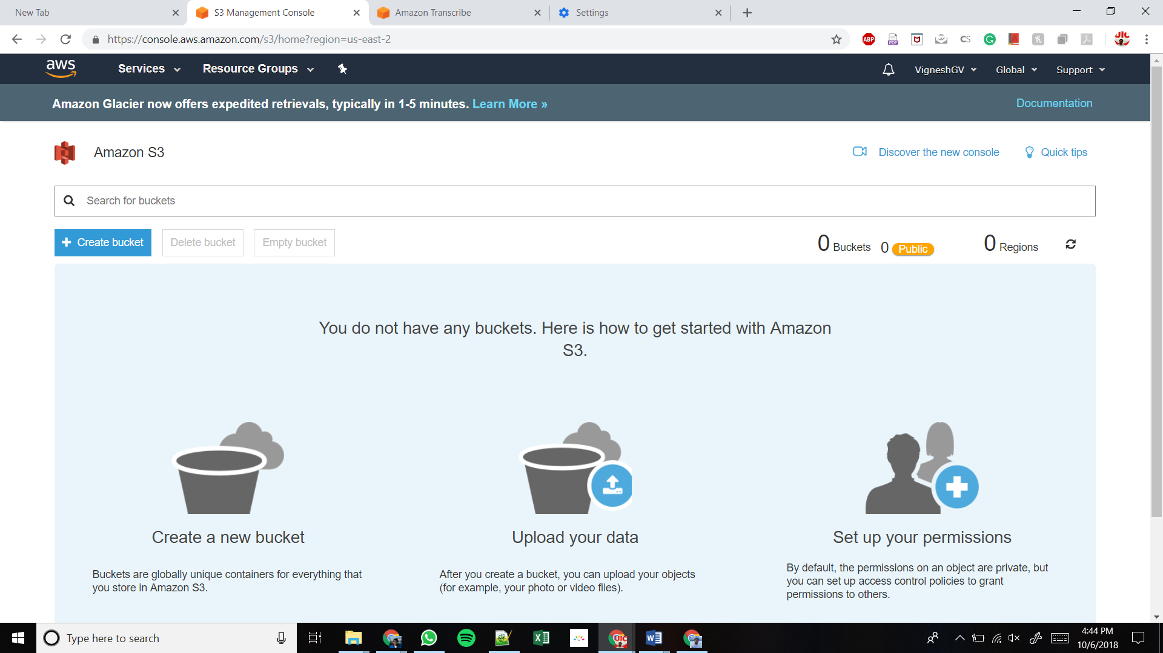The S3 interface looks like this:

* Click on Create bucket button.
* Give a bucket name in lower case
* You should specify a region for your bucket (Sometimes Amazon Transcribe will ask you to change the bucket zone – In that case delete the bucket that you have created in a different zone, and create a new bucket in the specific zone that Transcribe is asking you to create)
* To begin with, lets keep all other settings to default and click Next in each window and finally click on Create Bucket Button

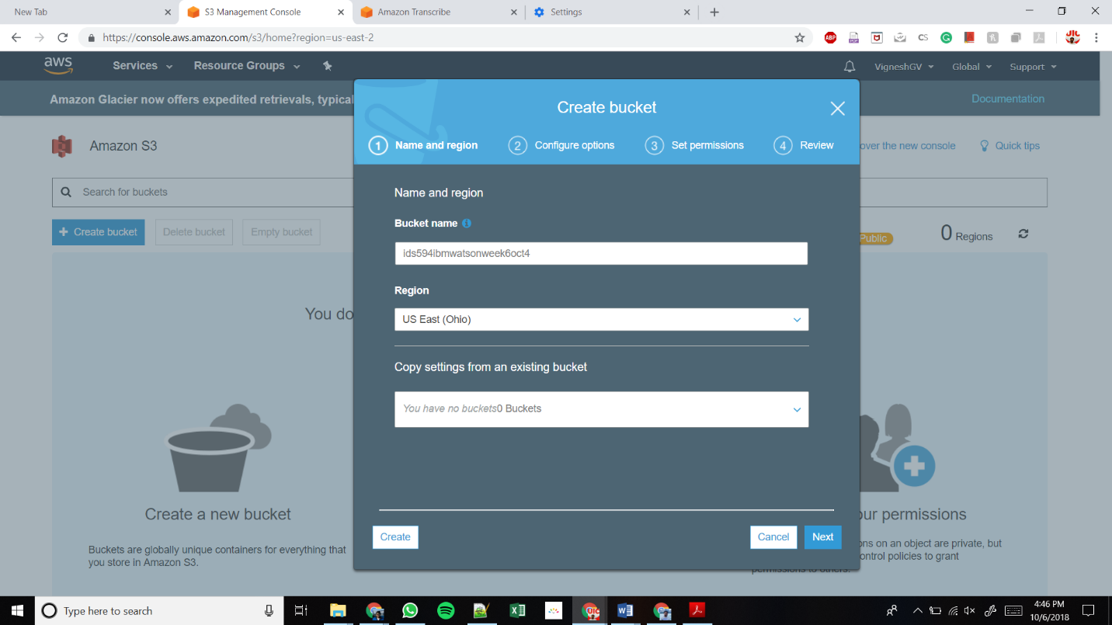

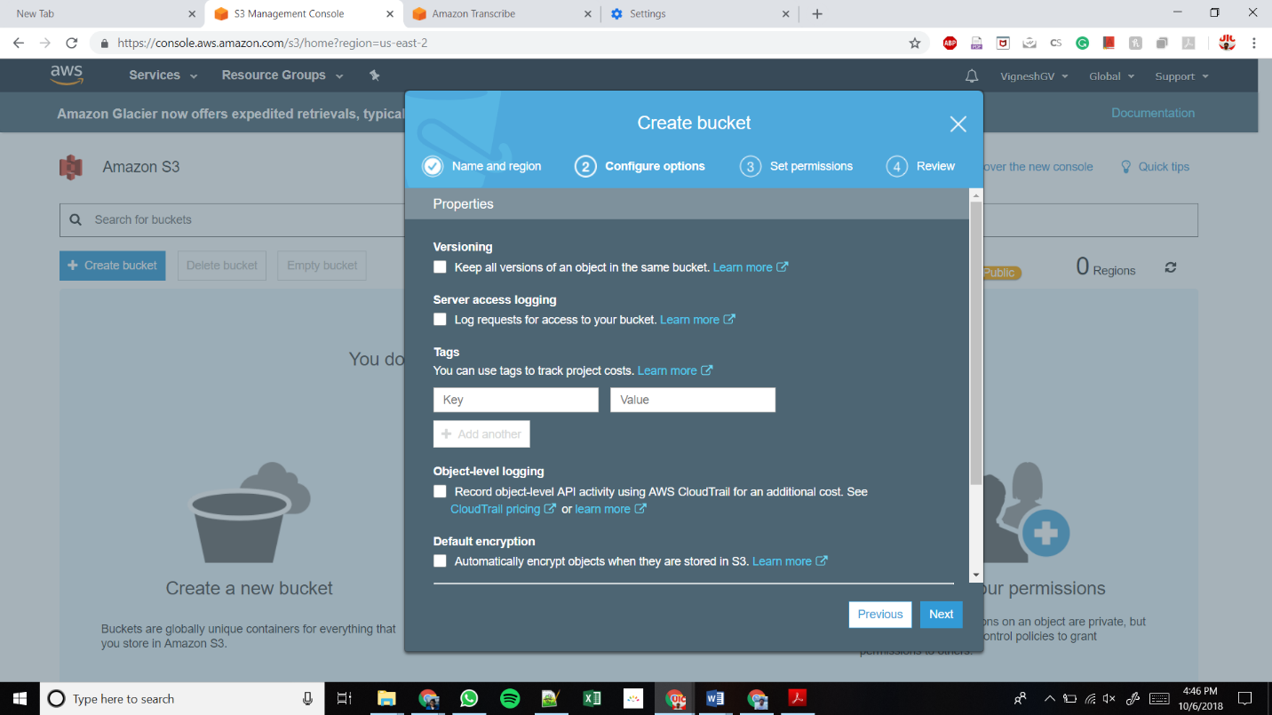

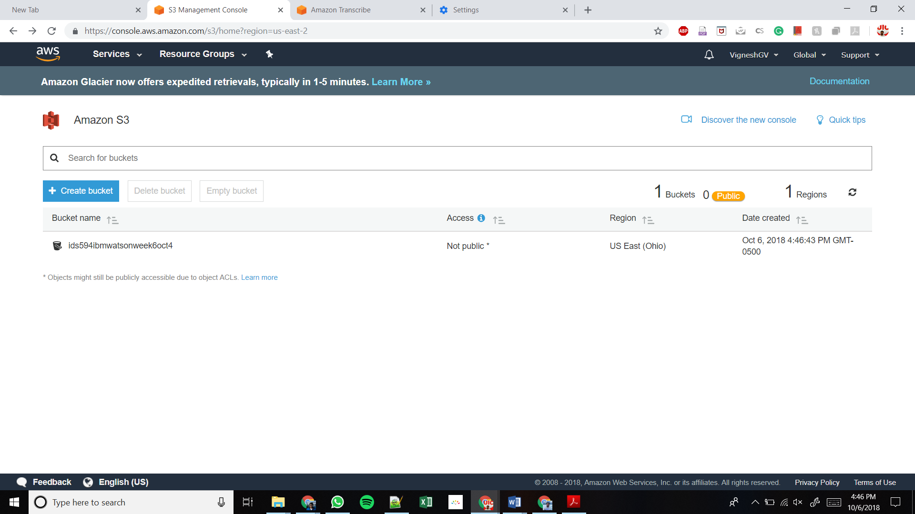

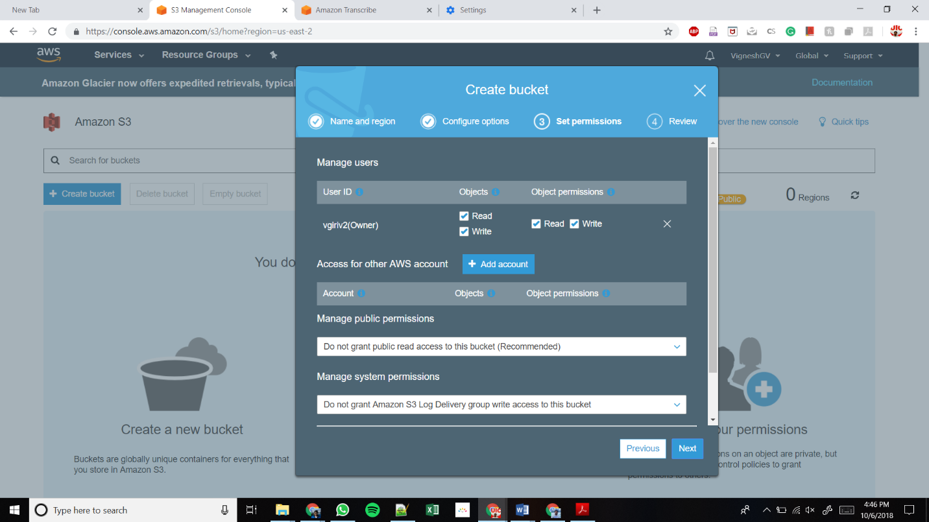

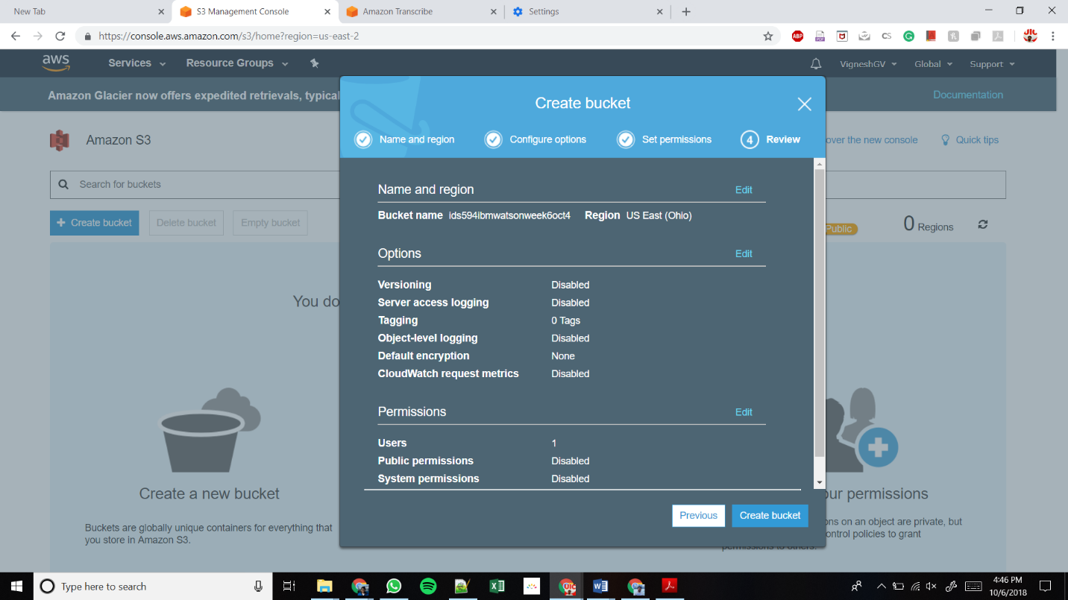

**Step-2: Uploading audio file (mp3, mp4) in the bucket**

* 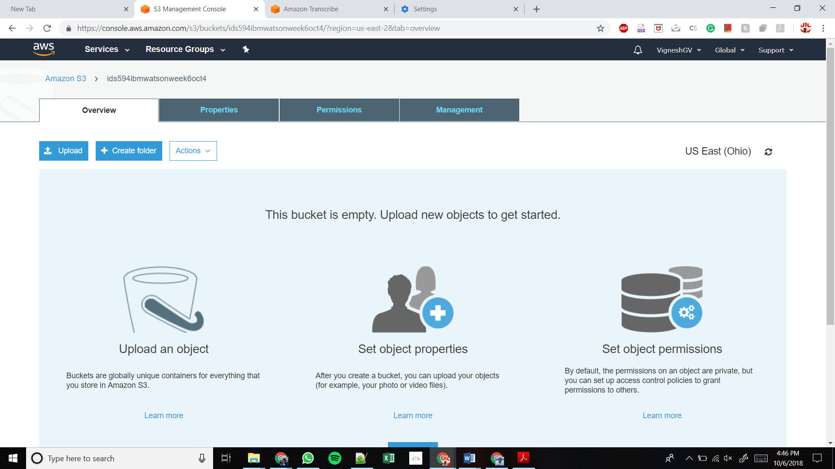After the bucket gets created, click on the bucket name.
* 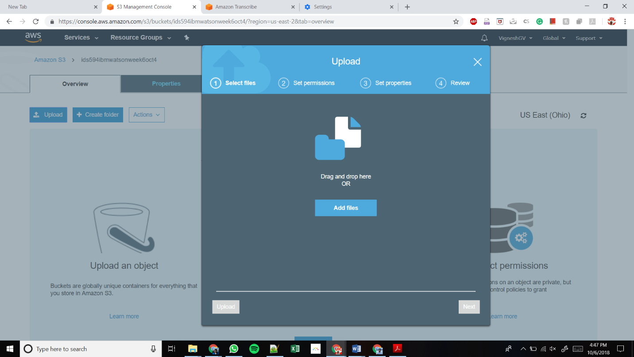Upload the audio file(s) that needs to be converted to text.
* 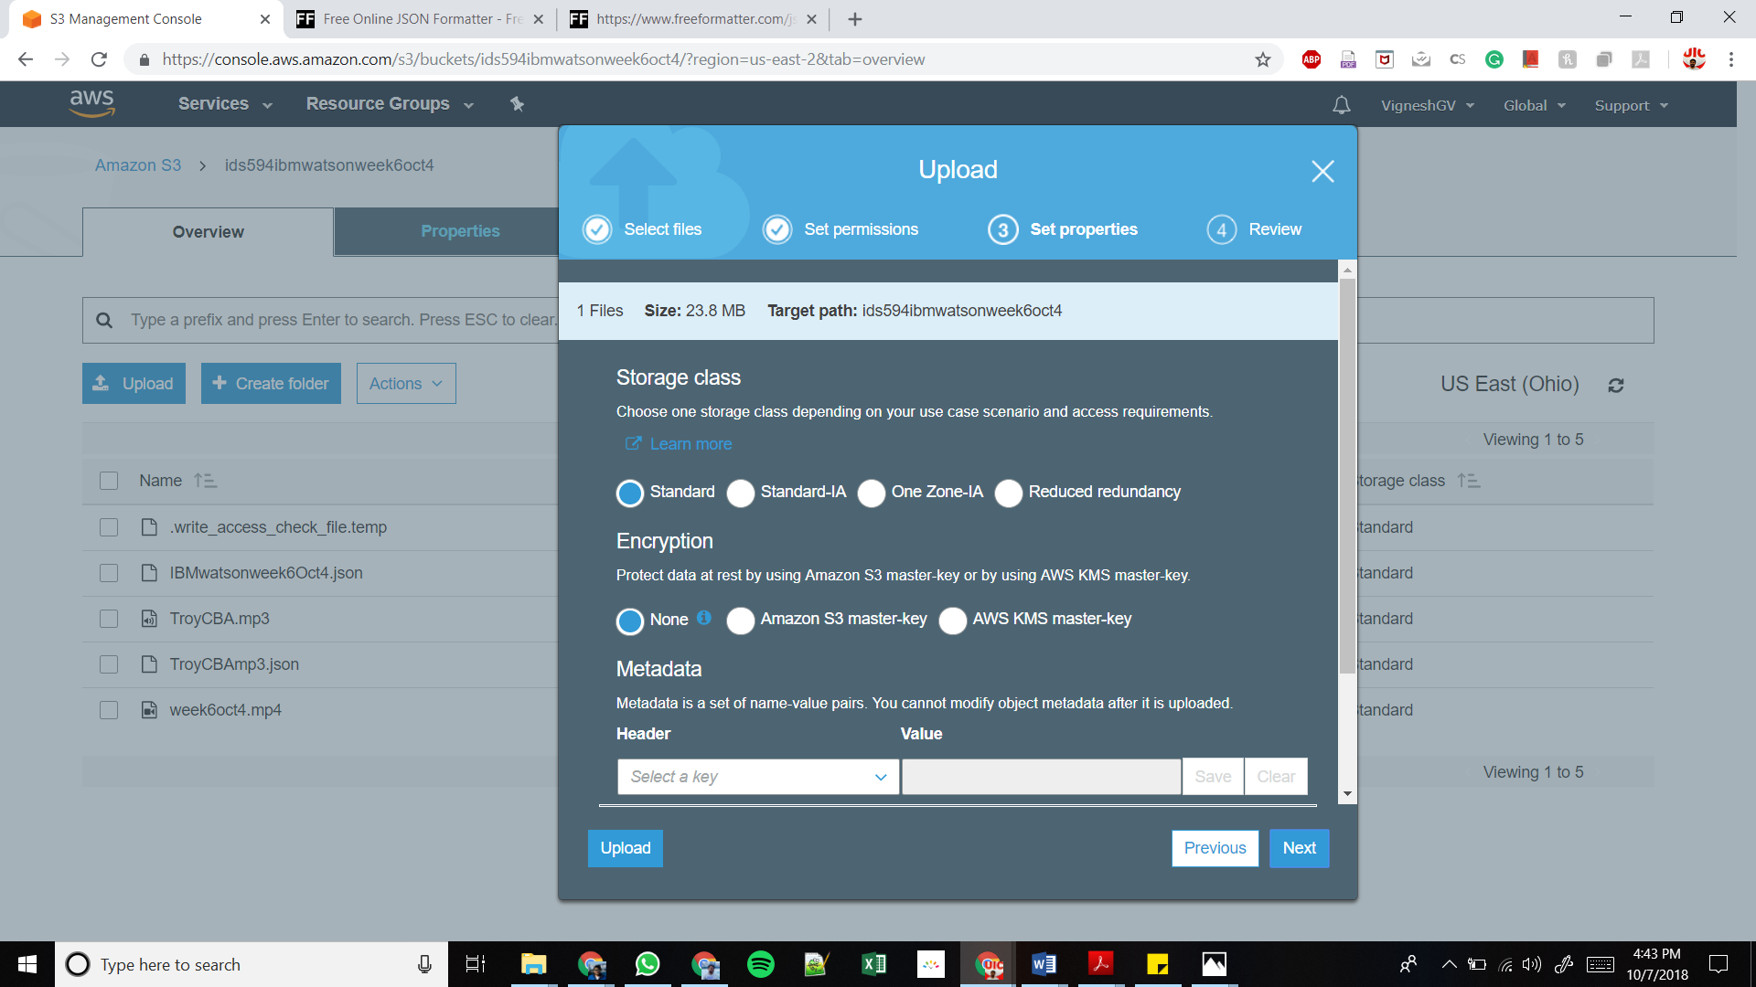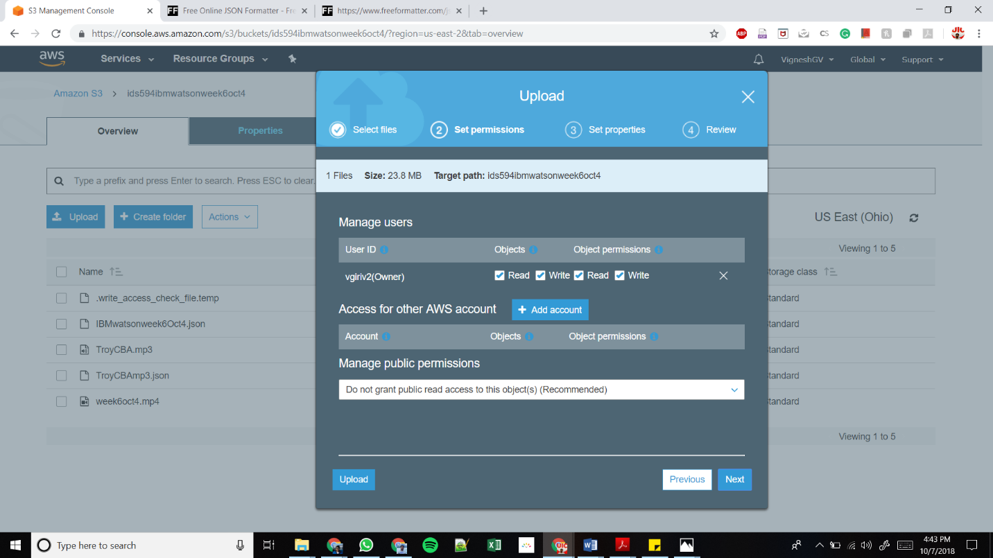Proceed through the next steps without changing any parameters if you are not sure about the set permissions and set properties options and finally click on the upload button.

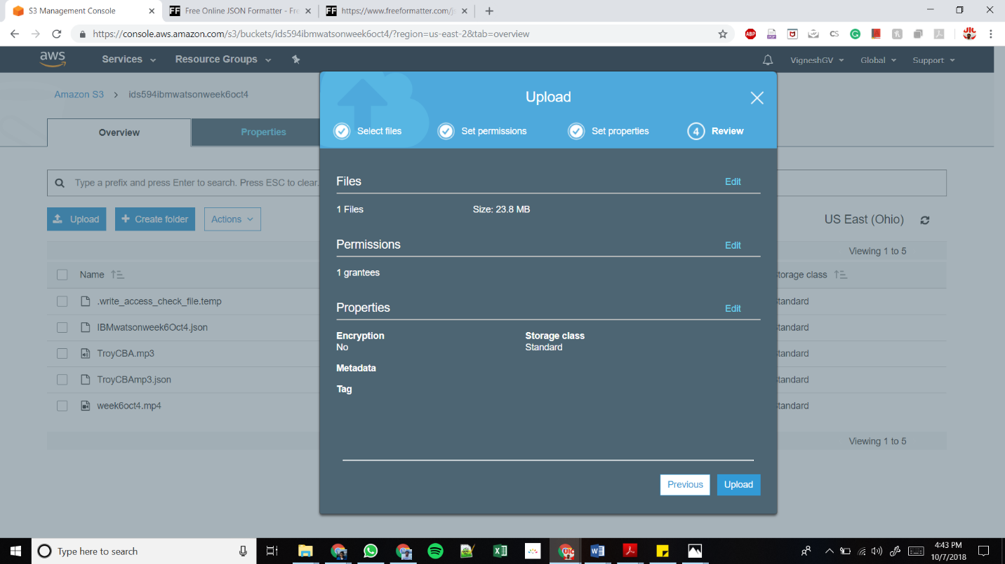

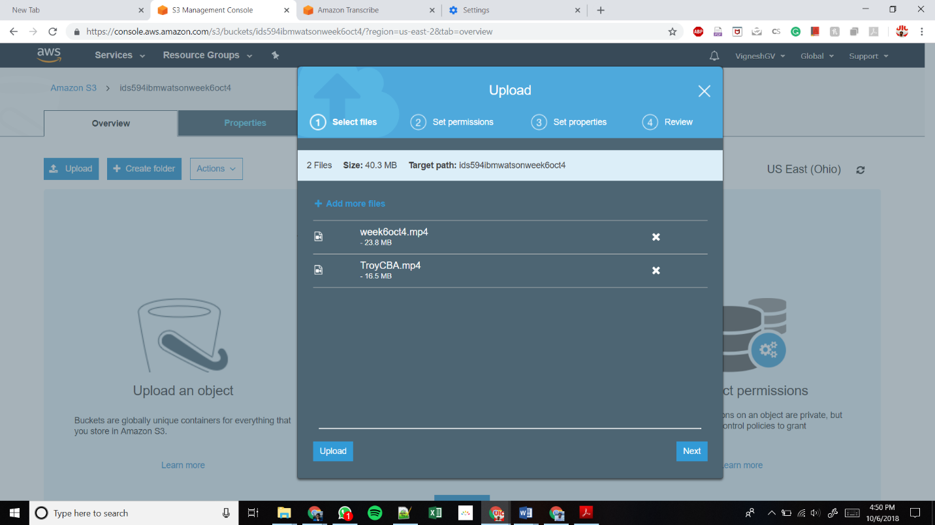

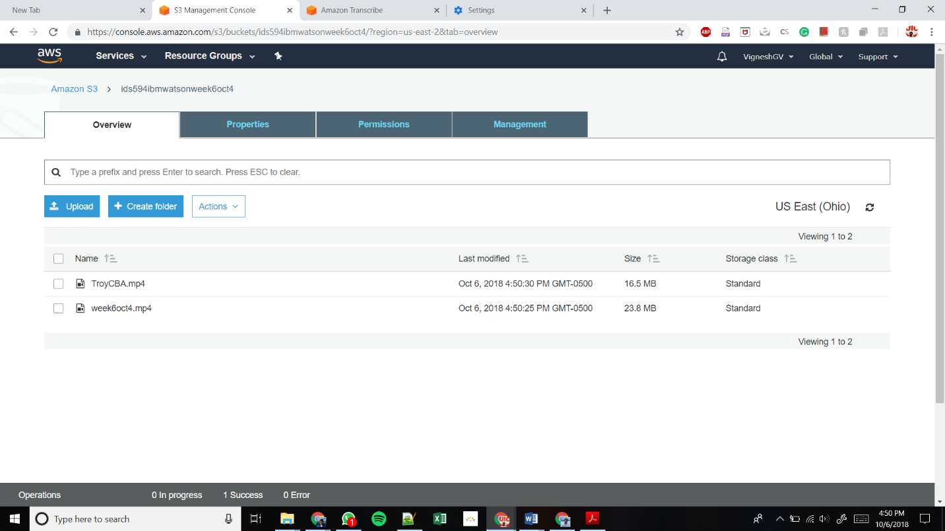

**Step – 3: Accessing Amazon Transcribe and initiate conversion**

* Open Amazon Transcribe by clicking on Try Amazon Transcribe

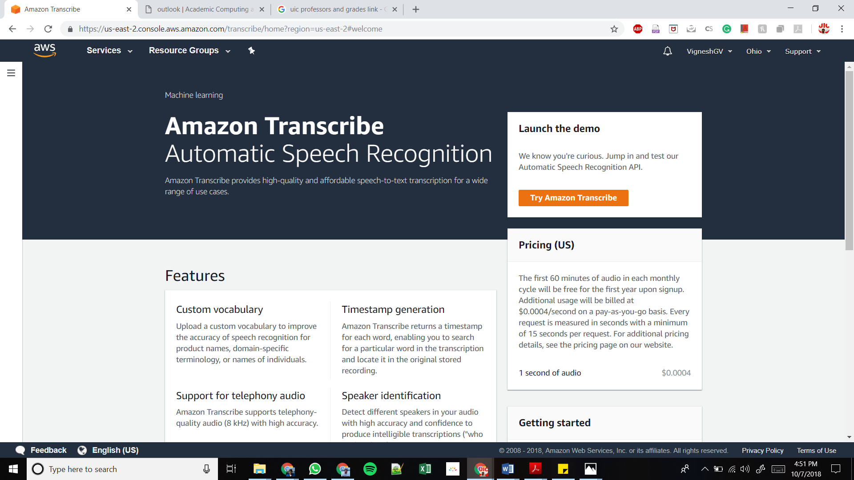

* Click on Create Job for creating your first job.

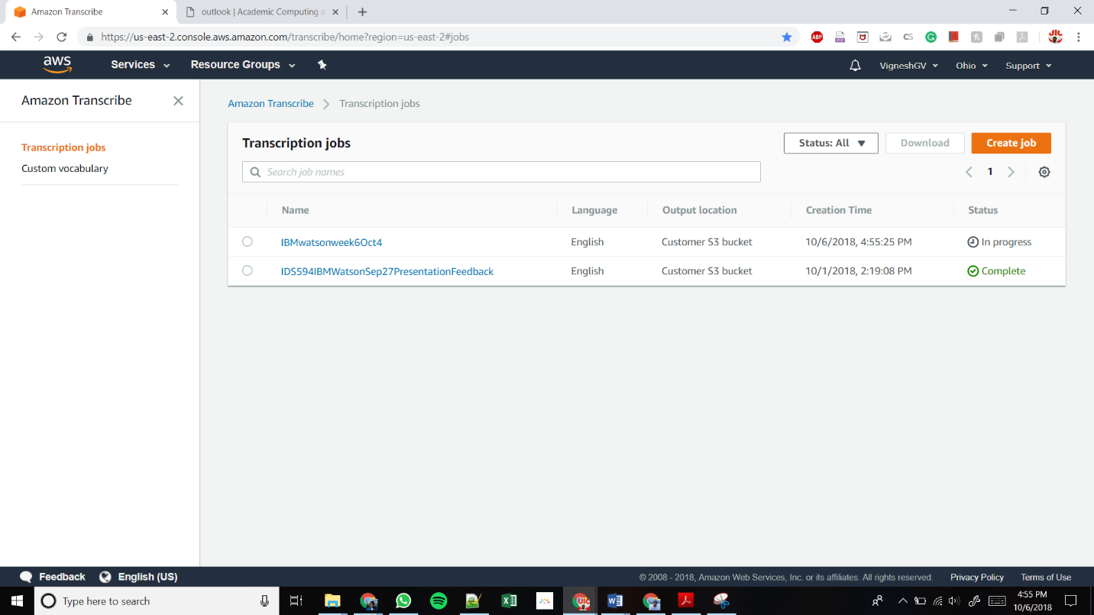

* To input all the fields given below, you need all the details of the mp3 file that you uploaded in S3

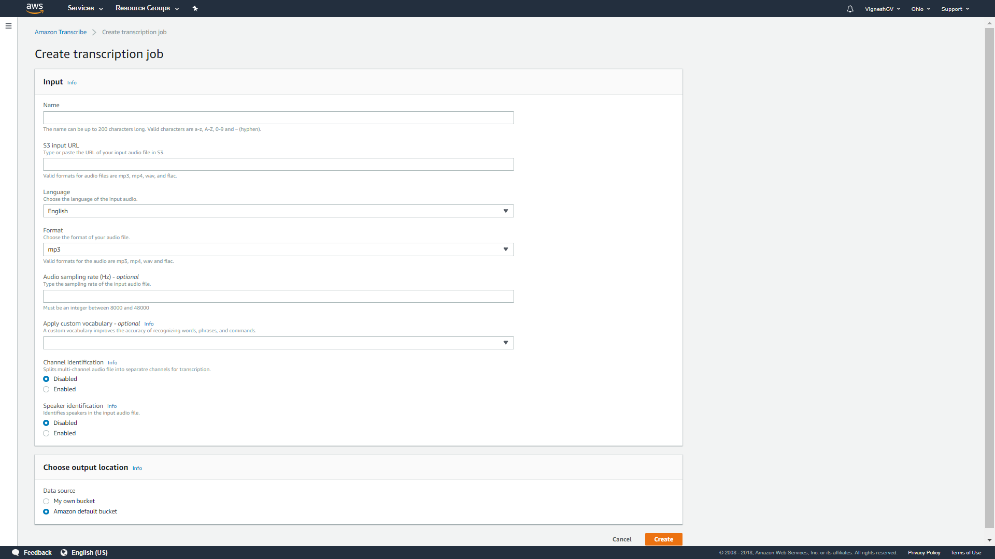

* Copy the link, bucket name and file name you gave for the mp3 file from below.

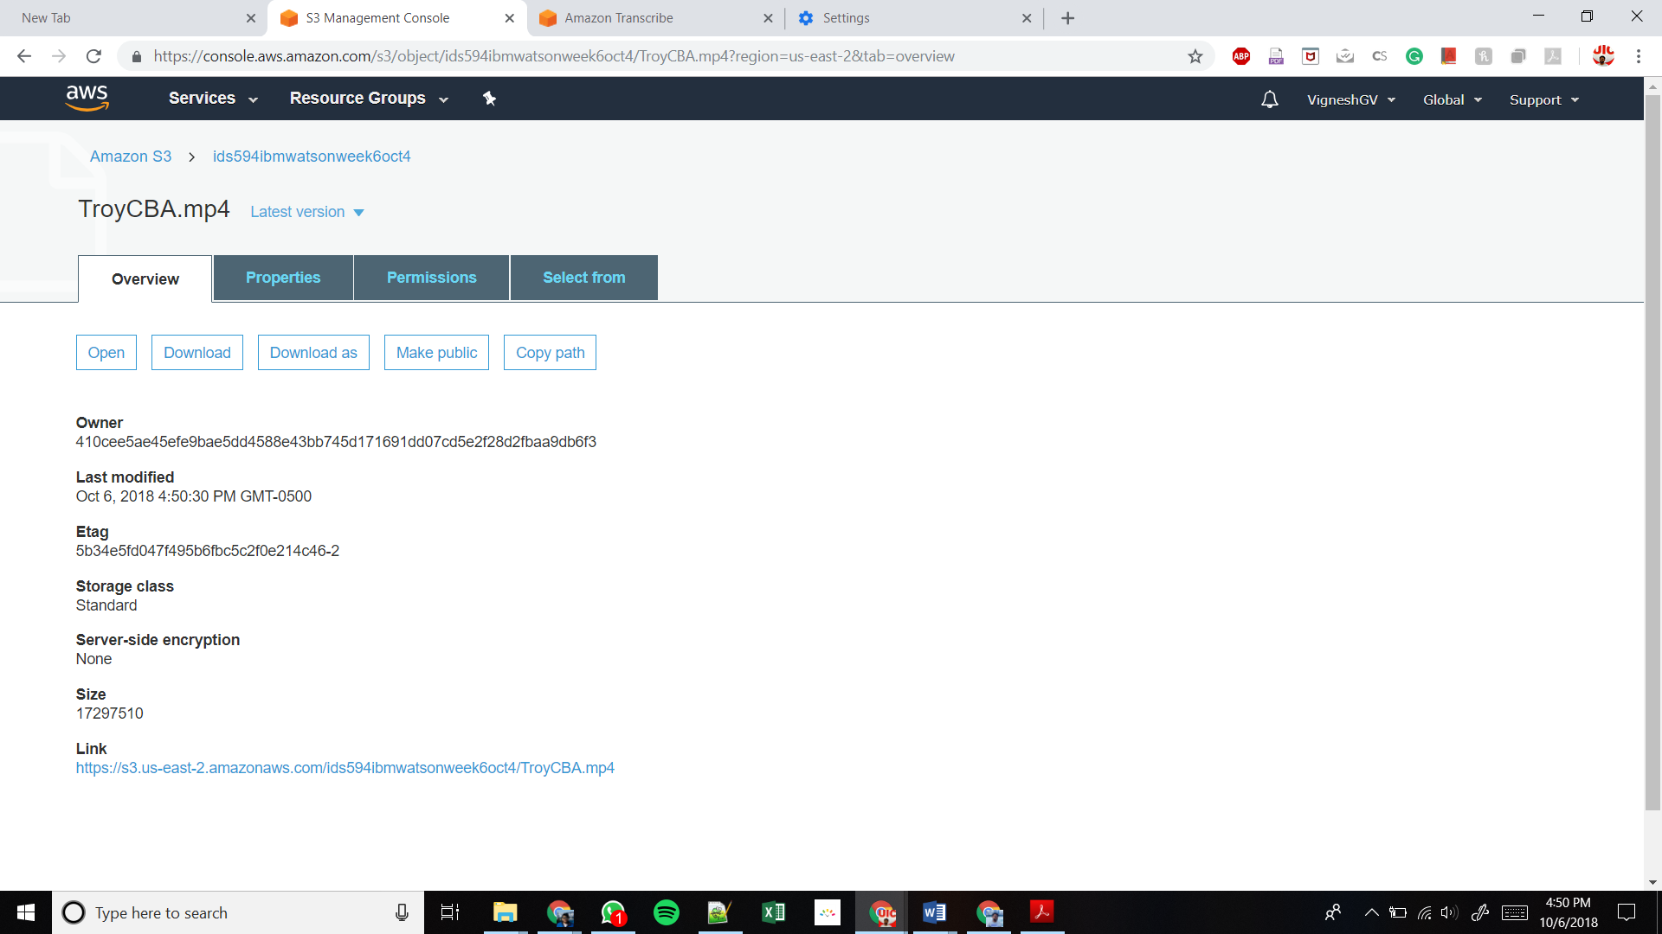

* Fill all the inputs you copied from the file details in the S3 bucket
* Provide appropriate File format (mp3 or mp4)
* Provide the number of speakers in the audio file for Speaker Identification option
* 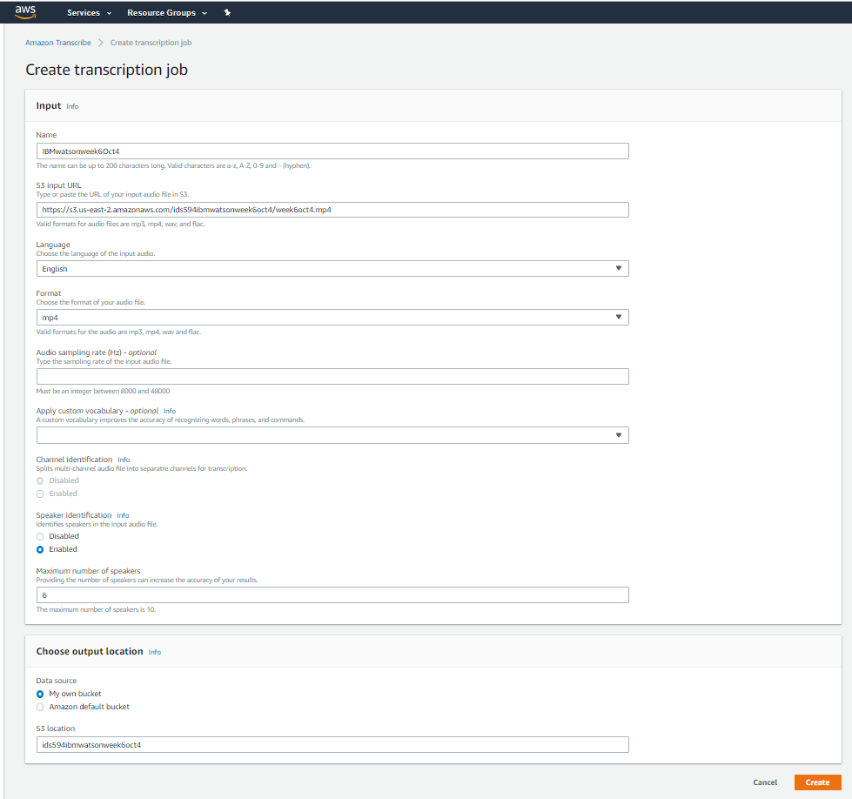You can choose the output location of the converted file – you can choose your own bucket or Amazon default bucket. I have used my own bucket by giving the bucket name as shown below
* Click create and the conversion job will begin with the status – In progress.

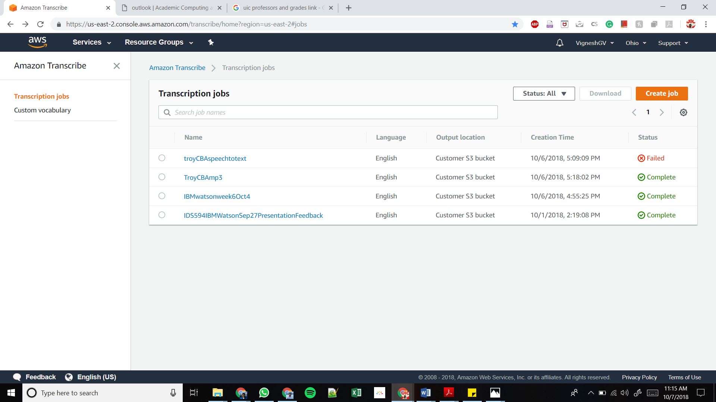

**Step-4: Converting json file to word format**

* Once the job gets completed click on the completed job to view the details

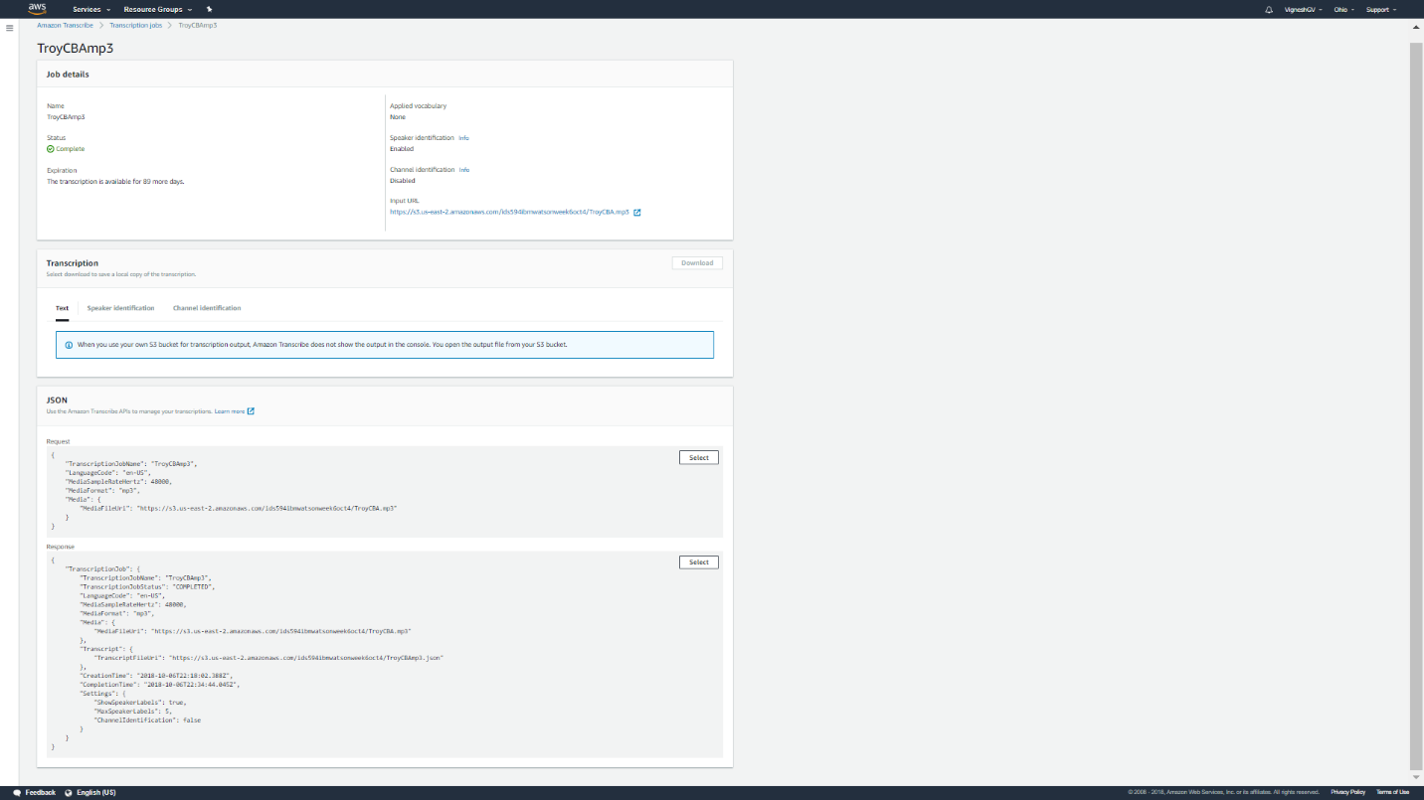

* 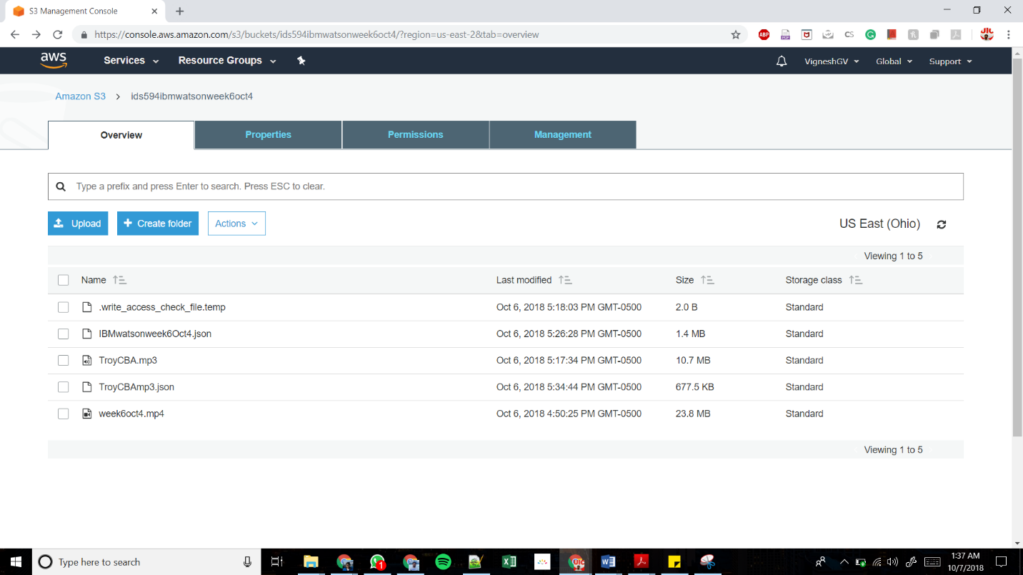Open your S3 bucket to view the converted json file.

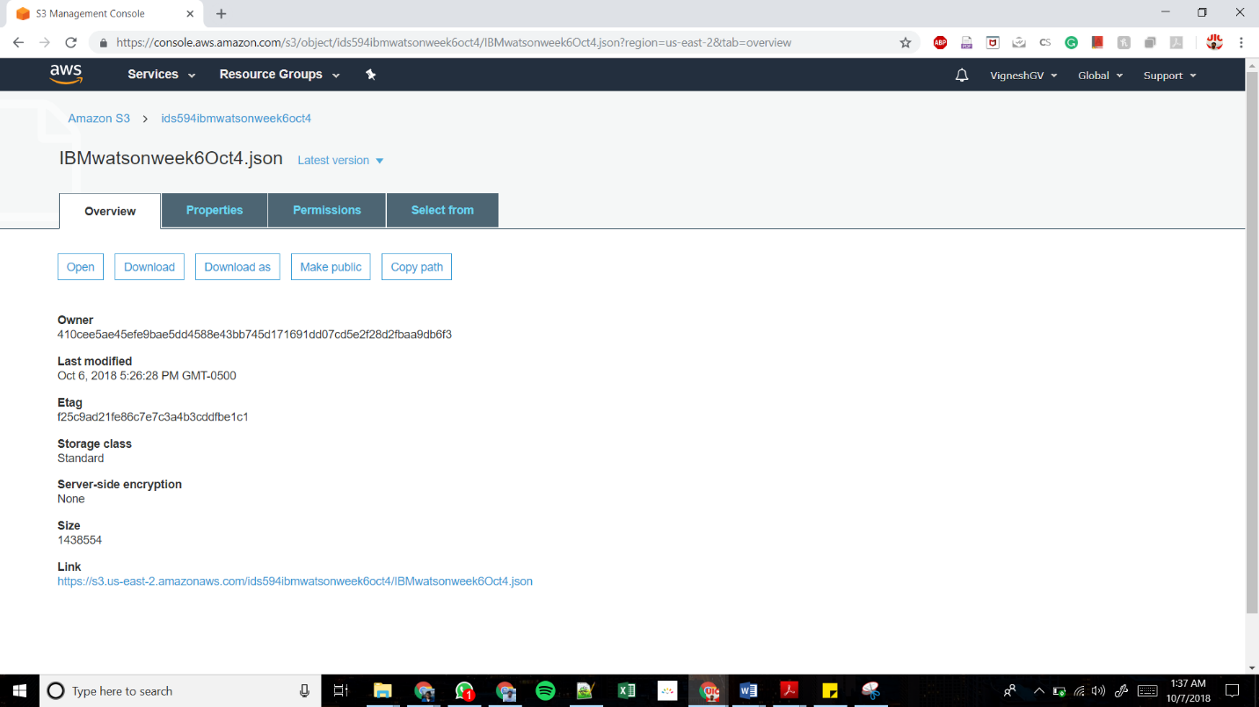

* Download the json file to convert it into readable word format.
* I have used an online resource called “freeformatter.com” to convert json to word

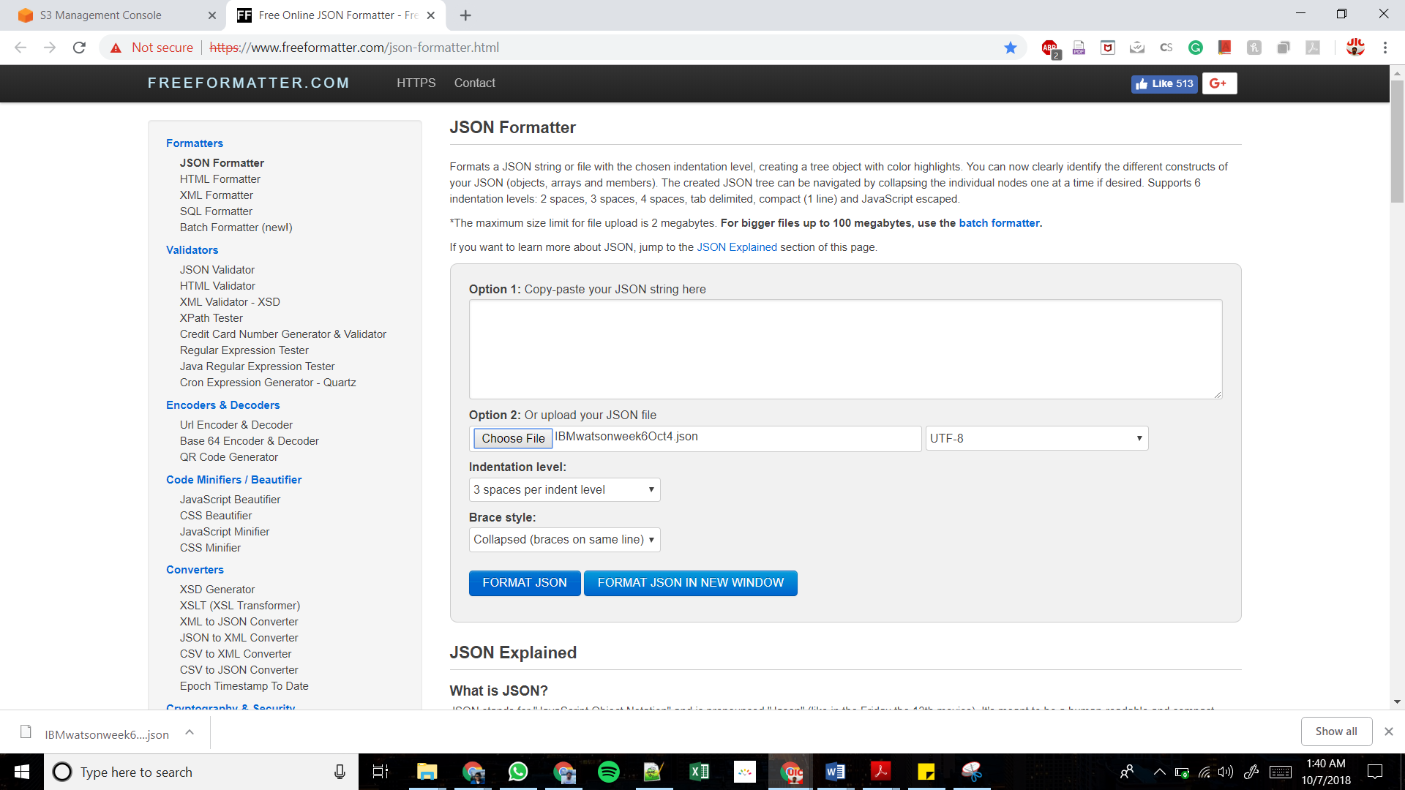

* The online tool converts the json format into word format as shown below.

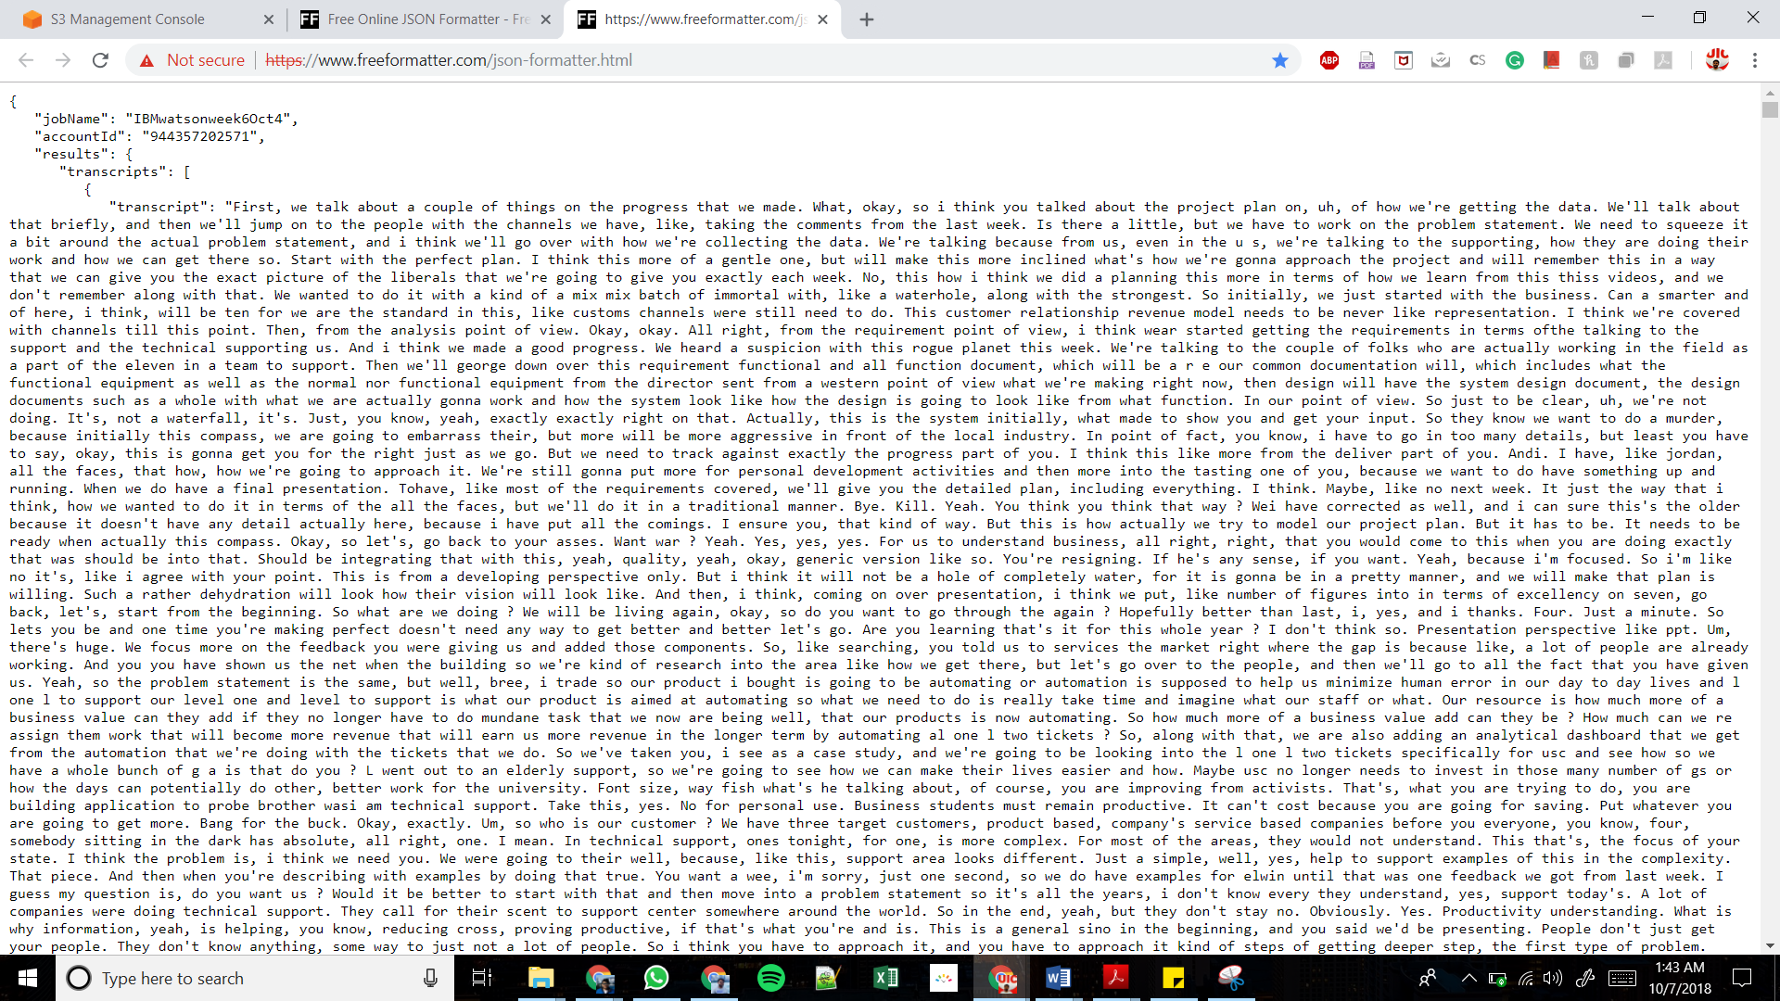

* The amazon transcribe is not accurate in terms of spelling and grammar. So, you can use spell check in MS word or a useful online resource called “Grammarly”. I have used both for arriving the final text document.

**Resources Used:**

* mp3, mp4 audio files
* AWS Amazon S3 and Amazon Transcribe
* <https://freeformatter.com/>
* <https://app.grammarly.com/>
* MS Word